Our Vision

To be a world class firm that is a benchmark for catalyzing business transformation for our customers, fulfilling employee aspirations & caring for our wider community through depth of thought leadership, customer centricity and execution excellence

.

SONATA SOFTWARE LTD
www.sonata-software.com

Business Requirements Document
for
Metrics Management System

Revision History

Version No. | Version date | Brief description | Prepared/ modified by | Approved by | Approval Date
0.1 | August 2024 | Draft version | CST
1.0 | July 2025 | Revised version based on the feedback , current process at Org | CST

Table of Contents

1. Project Summary 1
1.1. Project Objective 1
1.2. Business Objective 1
2. Scope 1
2.1. In Scope 1
2.2. Out of Scope functionality 2
3. System Perspective 2
3.1. Assumptions 2
3.2. Constraints 2
3.3. Dependencies 3
3.4. Risks 3
3.5. Issues 3
4. Business Process Overview 3
Proposed Business Process (To-Be) 3
5. Functional Requirements 4
5.1. Generic Requirements: 4
5.2. Centralized Masters 4
5.2.1. Account Master: 4
5.2.1.1. Provide an interface for creation of Account master 4
5.2.1.2. There should be an integration between SonataOne and MetricsManagement System to create account from SonataOne 4
5.2.2. Project Master: 4
5.2.2.1. Project master to be created as soon the project is initiated in SonataOne. 4
5.2.2.2. There should be an integration between SonataOne and MetricsManagement System to create project from SonataOne 4
5.2.2.3. Project metrics reporting frequency to be defined (Weekly / Fortnightly / Monthly). 4
5.2.3. Project phases: 4
5.2.3.1. User should be able to define and maintain project phases (Phase, Phase name, Planned start date, Planned end date, Actual Start date, Actual End date and status) 4
5.2.4. Other Masters 4
5.3. Definition of Metrics/KPI’s: 4
5.3.1. Organizational Level Metrics 5
5.3.1.1. Admin User should be able to define and maintain organizational level standard metrics based on the Project Type, Process Model and Project Category 5
5.3.1.2. Admin User should be able to set the parameters for the metrics. Refer the MetricsManagementSystem_Requirements.xlsx file for the fields required 5
5.3.1.3. Admin User should not be able to delete the metrics at organization level, if it is used at project level 5
5.3.2. Project Metrics 5
5.3.2.1. Project Manager should be able to define project specific metrics based on organization metrics. Parameters related to project specific metrics are defined in MetricsManagementSystem_Requirements.xlsx 5
5.3.2.2. Parameter values will be set based on the organization metrics and the same can be overridden at project level 5
5.3.2.3. System should ensure that project metrics should have minimum number of metrics that needs to be defined for each metrics category 5
5.3.2.4. User should not be able to delete the metrics at project level, if the data for the metrics already submitted 5
5.3.2.5. There should be a review and approval process by DM and CST for project metrics defined by the project manager. 5
5.4. Metrics data collection 6
5.4.1. Data Collection and Metrics Computation in App 6
5.4.1.1. There should be an interface to provision user (either PM or delegated persons) to enter/update data for each of the measures defined in metrics formula for the defined frequency/phase and duration 6
5.4.1.2. On submission of data, metrics to be automatically computed as per the formula 6
5.4.1.3. RAG rating to be derived based on the metric intent, Target, LSL and USL for the reporting frequency 6
5.4.1.4. Analysis comments to be captured by PM for each of the metrics depending on the RAG status 6
5.4.1.5. System should compute overall RAG status for the project metrics reporting frequency to be computed based on the RAG status of all the metrics. 6
5.4.1.6. If any one metrics RAG is “Red”, then overall RAG should be “Red”, if any one metrics RAG is “Amber”, then overall RAG should be “Amber” else it should be “Green” 6
5.4.1.7. PM should be able to give overall RAG status based on PMs perception and provide overall RAG comments. This should be captured in a separate field. Computed RAG status should not be allowed to override 6
5.4.1.8. Log of RAG status changes to be maintained 6
5.4.2. Data Collection (integration with the external systems) 6
5.4.2.1. Identify and integrate data sources such as databases, applications and APIs. Support various data formats (CSV, JSON, XML) for seamless data integration. Enable real-time data collection for immediate insights and responsiveness. 6
5.4.3. Integration & Compatibility: 6
5.4.3.1. Integrate with external tools and platforms (e.g., ALM, CRM, ERP systems) for seamless data flow. Offer APIs for custom integrations and data retrieval. Ability to maintain large datasets 6
5.5. Metrics Monitoring and Governance 6
5.5.1. Metrics Review 6
5.5.1.1. Metrics along with trend to be shown for the selected project metrics based on reporting frequency 6
5.5.1.2. DM, DD and DH – able to review the metrics data and metrics submitted by PMs and provide their commentary for the reporting frequency (Fortnightly/weekly/monthly basis). The comments should be at project level for the defined frequency and should be able to override the comments already available 6
5.5.1.3. Separate fields to be maintained for each of the role and their respective comments along with the date and review status 7
5.5.1.4. PM should be able to track and close all the actions based on the feedback provided by DM / DD / DH 7
5.5.2. Governance 7
5.5.2.1. Governance reviews at BU, Account or Project level to be provided 7
5.5.2.2. Comments on outcome of the Governance to be captured 7
5.5.2.3. Action Plan setting on Governance 7
5.5.2.4. Action Plan Tracking & Closure 7
5.5.2.5. Auto Creation Power Point Decks with Metrics Performance for Governance meetings 7
5.5.3. Alerts/Notifications 7
5.5.3.1. As per project metrics reporting frequency alerts to be sent to PM for updating the metrics 7
5.5.3.2. Alerts to be triggered to next level if the metrics updates are not done within the defined threshold (Threshold to be configurable) 7
5.5.3.3. On metrics submission, DM, DD , DH and CST partner to be notified about the same 7
5.5.3.4. Alerts to be triggered to next level if the review of metrics not done within the defined threshold (Threshold to be configurable) either DM, DD or DH 7
5.5.3.5. All alerts or notifications to be copied to respective CST partners 7
5.5.3.6. Notification to be sent to PM, DM, DD, DH and CST partner whenever review updates are done 7
5.5.4. Metric Analysis: 7
5.5.4.1. Metrics trend and analysis at various levels of Entities and frequency. 7
5.5.4.2. Assess historical data, discover patterns, observe trends, and use that information to predict future trends as part of Predictive Analysis. 7
5.5.4.3. Enable Root cause Analysis to identify root causes for any Positive or negative trend. 7
5.5.4.4. Action Plan setting on Analysis 7
5.5.4.5. Action Plan Tracking & Closure 7
5.6. Data Visualization & Reporting 7
5.6.1.1. Provide all MIS reports. Support a variety of chart types (line charts, bar charts, pie charts) for diverse data representation. Enable interactive features such as drilldowns, filters, and tooltips. 8
5.6.1.2. Compliance reporting should happen from the tool. How many PMs have not submitted the data for how many fortnights, how many reviews are not done by DMs/DDs/DHs etc. 8
5.6.1.3. A dashboard that displays the summary and overview for the selected PL, account, Project, DD, DM or PM 8
5.6.1.4. Overall RAG report with a drill down report 8
5.6.1.5. User should be able to export and share the reports in different formats, such as PDF, Excel, CSV, or HTML. 8
5.6.1.6. Average Metrics values for the selected frequencies for each metrics 8
5.6.1.7. Compliance reporting should happen from the tool. How many PMs have not submitted the data for how many fortnights, how many reviews are not done by DMs/DDs/DHs etc. 8
5.7. Metrics Historical Database and Baselines 8
5.7.1. Metrics Baselines 8
5.7.1.1. Manage and track Baselines & define Targets &Thresholds at the account level by project type. (Segmentation of metrics based on project type, technology, sizing technique and methodology) 8
5.7.2. Metrics Historical Database 8
5.7.2.1. Maintenance of org level metrics database to scale up for Predictive & Prescriptive Analysis 8
5.7.2.2. Visual Representation of Historical data at Entity level(From the collected data) 8
5.8. Administration 8
5.8.1.1. System should be allowed to define users and roles 8
5.8.1.2. Users should be able to define and maintain masters / configurations 8
5.8.1.3. Able to define the access rights at various level as below 8
5.9. Configurations 9
5.9.1. Governance Workflow 9
5.9.1.1. DH, DD, DM review frequency(Weekly, Fortnightly, Monthly, Quarterly) to be defined 9
5.9.2. Thresholds for alerts to be defined 9
5.9.3. Application Settings 9
5.10. Non-Functional Requirements 9
6. Annexure A 9

Project Summary

Project Name | Sonata-Metrics Management System
Project Type | Development
Project Start Date
Project End Date
Project Sponsor

Project Objective

Metrics management System aims to provide a robust platform for defining, tracking, and managing key performance indicators (KPIs) within an organization.
Objective is to make the platform as the platform delivery management for executing a project. Project performance parameters are recorded and reported with transparency.
Bring in visibility of the metrics reported by projects/programs by project type.
For three tier governance through the tool
Reporting of RAG status and reporting of Business Unit (BU) Watchlist and Organization (Org)Watchlist
The tool will help the stakeholders to identify the strengths and weaknesses of respective projects/programs and to make informed decisions for improvement and optimization.
The tool will also help the stakeholders to communicate and collaborate more effectively, and to align their goals and expectations.

Business Objective

Following are the benefits through Metrics Management System.

Centralized Project Database
Metrics Tracking & Analysis
Project Health Visibility
Data based Governance
Early warning
Baselines at account level
Process Improvement Action Planning & Tracking

Scope

In Scope
Following the high level scope
- Centralized Project database:
  - Creation & Maintaining All types of projects in the organization with all required attributes. Provide Integration of SonataOne Projects into the system.
- Definition of Metrics/KPI’s:
  - Depending on the project type, ability to customize metrics applicable to the project, define/use standard metrics. Once the metrics is identified for a project, project should be able to capture the metrics at a certain frequency (Fortnightly).
  - Setting of various parameters for the metrics like Target, USL and SSL at Organization level or project level
  - Organization Measurable Objectives Setting, Project Measurable Objectives setting.
  - Data Collection within the system
- Data Collection (integration with the external systems):
  - Identify and integrate data sources such as databases, applications and APIs. Support various data formats (CSV, JSON, XML) for seamless data integration. Enable real-time data collection for immediate insights and responsiveness.
- Metrics Monitoring:
  - Monitor key metrics in real-time and trigger alerts for anomalies or threshold breaches. Provide customizable alerting mechanisms (email, SMS, notifications) for immediate response to critical metrics deviations.
- Metric Analysis:
  - Metrics trend and analysis at various levels of Entities and frequency. Assess historical data, discover patterns, observe trends, and use that information to predict future trends as part of Predictive Analysis. Enable Root cause Analysis to identify root causes for any Positive or negative trend.
- Metrics Baselines :
  - Manage and track Baselines & define Targets &Thresholds at the account level by project type. (Segmentation of metrics based on project type, technology, sizing technique and methodology)
- Metrics Historical Database:
  - Maintenance of org level metrics database to scale up for Predictive & Prescriptive Analysis
- Data Visualization & Reporting:
  - Provide drag-and-drop interfaces for creating customizable dashboards. Support a variety of chart types (line charts, bar charts, pie charts) for diverse data representation. Enable interactive features such as drilldowns, filters, and tooltips.
- Data Governance: 3 tier Governance to be implemented.
  - Provide data lineage tracking to understand the origin and transformation of data. Derive and report Project Health using Project performance data against measurable project objectives and other qualitative information. Provided Customized dashboards for quick decision making.
- Integration & Compatibility:
  - Integrate with external tools and platforms (e.g., ALM, CRM, ERP systems) for seamless data flow. Offer APIs for custom integrations and data retrieval. Ability to maintain large datasets

Out of Scope functionality

System Perspective

Assumptions

# | Assumptions

Constraints
# | Constraints

Dependencies

Risks

Issues

Business Process Overview

Proposed Business Process (To-Be)
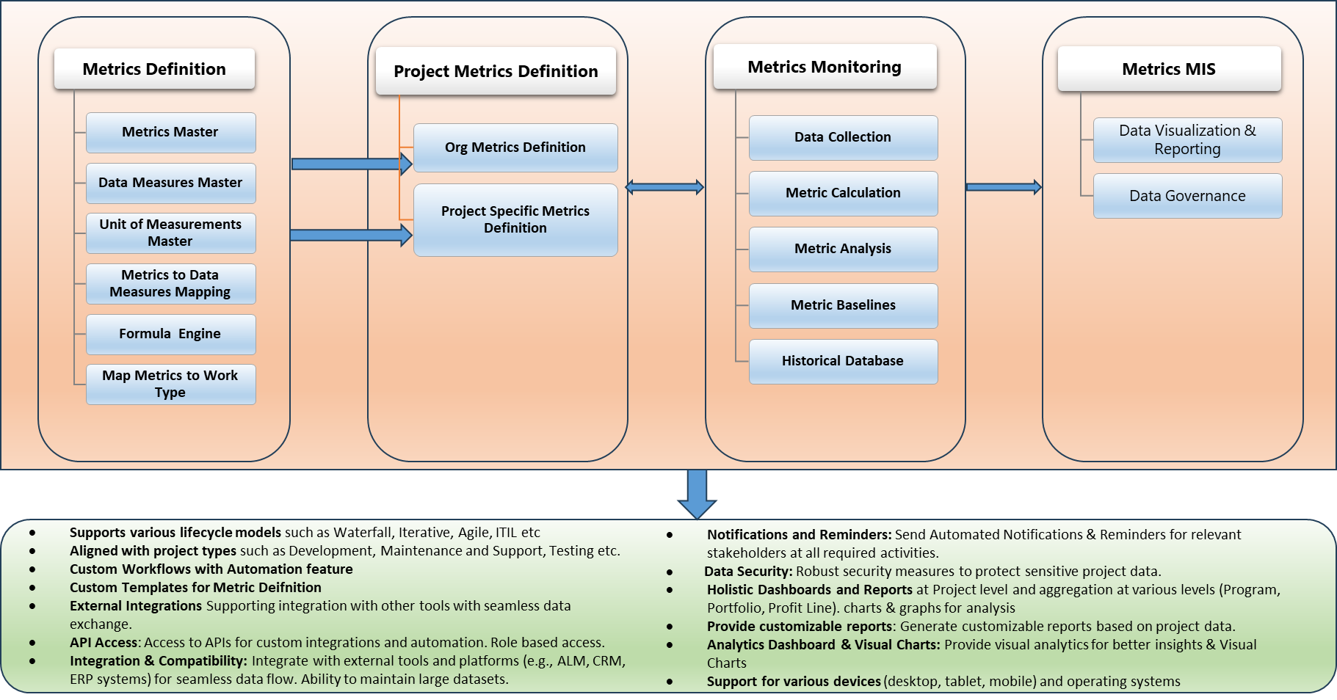

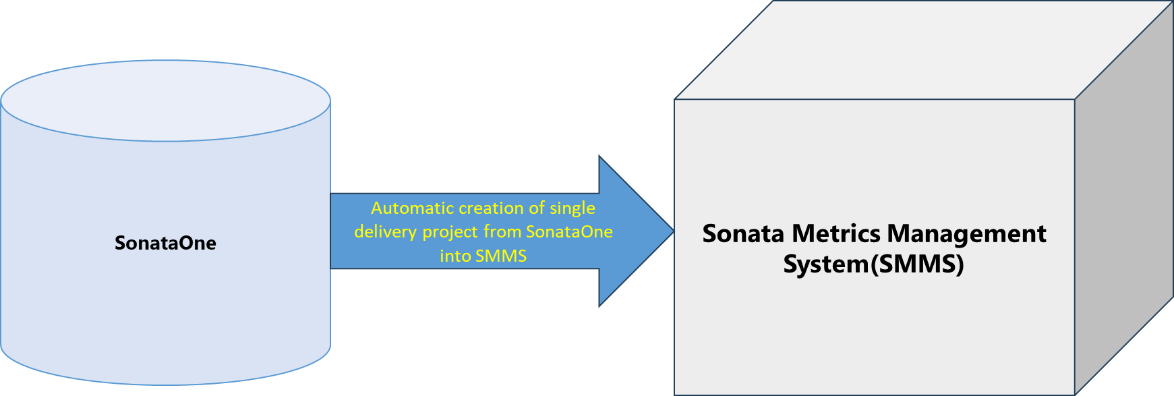

Functional Requirements

Generic Requirements:
- A web-based user interface that allows the users to access, navigate, and interact with the tool from any device and browser.

Centralized Masters

Account Master:

Provide an interface for creation of Account master

There should be an integration between SonataOne and MetricsManagement System to create account from SonataOne

Project Master:

Project master to be created as soon the project is initiated in SonataOne.

There should be an integration between SonataOne and MetricsManagement System to create project from SonataOne

Project metrics reporting frequency to be defined (Weekly / Fortnightly / Monthly).

Project phases:

User should be able to define and maintain project phases (Phase, Phase name, Planned start date, Planned end date, Actual Start date, Actual End date and status)

Ex: Sprint, Sprint1, 01 Jul 2024, 15 Jul 2024,, 02 Jul 2024, 15 Jul 2024, Completed
Release, Release1, 01 Jul 2024, 15 Jul 2024,, 02 Jul 2024, 15 Jul 2024, Completed
Milestone, Design , 01 Jul 2024, 15 Jul 2024,, 02 Jul 2024, 15 Jul 2024, Completed

Other Masters
  - Refer the MetricsManagementSystem_Requirements.xlsx for all other masters and for the fields required in all the master tables

Definition of Metrics/KPI’s:
Ability to define/use standard metrics, Organization Measurable Objectives Setting, Project Measurable Objectives setting.

Organizational Level Metrics

Admin User should be able to define and maintain organizational level standard metrics based on the Project Type, Process Model and Project Category

Admin User should be able to set the parameters for the metrics. Refer the MetricsManagementSystem_Requirements.xlsx file for the fields required

Admin User should not be able to delete the metrics at organization level, if it is used at project level

Project Metrics

Project Manager should be able to define project specific metrics based on organization metrics. Parameters related to project specific metrics are defined in MetricsManagementSystem_Requirements.xlsx

Parameter values will be set based on the organization metrics and the same can be overridden at project level

System should ensure that project metrics should have minimum number of metrics that needs to be defined for each metrics category

User should not be able to delete the metrics at project level, if the data for the metrics already submitted

There should be a review and approval process by DM and CST for project metrics defined by the project manager.

Refer the MetricsManagementSystem_Requirements.xlsx file for the fields required

Metrics data collection

Data Collection and Metrics Computation in App

There should be an interface to provision user (either PM or delegated persons) to enter/update data for each of the measures defined in metrics formula for the defined frequency/phase and duration

On submission of data, metrics to be automatically computed as per the formula

RAG rating to be derived based on the metric intent, Target, LSL and USL for the reporting frequency

Analysis comments to be captured by PM for each of the metrics depending on the RAG status

System should compute overall RAG status for the project metrics reporting frequency to be computed based on the RAG status of all the metrics.

If any one metrics RAG is “Red”, then overall RAG should be “Red”, if any one metrics RAG is “Amber”, then overall RAG should be “Amber” else it should be “Green”

PM should be able to give overall RAG status based on PMs perception and provide overall RAG comments. This should be captured in a separate field. Computed RAG status should not be allowed to override

Log of RAG status changes to be maintained

Data Collection (integration with the external systems)

Identify and integrate data sources such as databases, applications and APIs. Support various data formats (CSV, JSON, XML) for seamless data integration. Enable real-time data collection for immediate insights and responsiveness.

Integration & Compatibility:

Integrate with external tools and platforms (e.g., ALM, CRM, ERP systems) for seamless data flow. Offer APIs for custom integrations and data retrieval. Ability to maintain large datasets

Metrics Monitoring and Governance

Metrics Review

Metrics along with trend to be shown for the selected project metrics based on reporting frequency

DM, DD and DH – able to review the metrics data and metrics submitted by PMs and provide their commentary for the reporting frequency (Fortnightly/weekly/monthly basis). The comments should be at project level for the defined frequency and should be able to override the comments already available

Separate fields to be maintained for each of the role and their respective comments along with the date and review status

PM should be able to track and close all the actions based on the feedback provided by DM / DD / DH

Governance

Governance reviews at BU, Account or Project level to be provided

Comments on outcome of the Governance to be captured

Action Plan setting on Governance

Action Plan Tracking & Closure

Auto Creation Power Point Decks with Metrics Performance for Governance meetings

Alerts/Notifications

As per project metrics reporting frequency alerts to be sent to PM for updating the metrics

Alerts to be triggered to next level if the metrics updates are not done within the defined threshold (Threshold to be configurable)

On metrics submission, DM, DD , DH and CST partner to be notified about the same

Alerts to be triggered to next level if the review of metrics not done within the defined threshold (Threshold to be configurable) either DM, DD or DH

All alerts or notifications to be copied to respective CST partners

Notification to be sent to PM, DM, DD, DH and CST partner whenever review updates are done

Metric Analysis:

Metrics trend and analysis at various levels of Entities and frequency.

Assess historical data, discover patterns, observe trends, and use that information to predict future trends as part of Predictive Analysis.

Enable Root cause Analysis to identify root causes for any Positive or negative trend.

Action Plan setting on Analysis

Action Plan Tracking & Closure

Data Visualization & Reporting

Provide all MIS reports. Support a variety of chart types (line charts, bar charts, pie charts) for diverse data representation. Enable interactive features such as drilldowns, filters, and tooltips.
The metrics reporting tool should allow the users to generate reports by selecting the metrics, the project reporting frequency, and the format (graphical or tabular) of the report. The tool will display the summary and trend of the selected metrics on the screen. The users can also export the report as a PDF or Excel file

Compliance reporting should happen from the tool. How many PMs have not submitted the data for how many fortnights, how many reviews are not done by DMs/DDs/DHs etc.

A dashboard that displays the summary and overview for the selected PL, account, Project, DD, DM or PM

Overall RAG report with a drill down report

User should be able to export and share the reports in different formats, such as PDF, Excel, CSV, or HTML.

Average Metrics values for the selected frequencies for each metrics

Compliance reporting should happen from the tool. How many PMs have not submitted the data for how many fortnights, how many reviews are not done by DMs/DDs/DHs etc.

Metrics Historical Database and Baselines

Metrics Baselines

Manage and track Baselines & define Targets &Thresholds at the account level by project type. (Segmentation of metrics based on project type, technology, sizing technique and methodology)

Metrics Historical Database

Maintenance of org level metrics database to scale up for Predictive & Prescriptive Analysis

Visual Representation of Historical data at Entity level(From the collected data)

Administration

System should be allowed to define users and roles

Users should be able to define and maintain masters / configurations

Able to define the access rights at various level as below

Configurations

Governance Workflow

DH, DD, DM review frequency(Weekly, Fortnightly, Monthly, Quarterly) to be defined

Thresholds for alerts to be defined

Application Settings

Non-Functional Requirements

The below mentioned non–functional requirements need to be mentioned in this section

Type | Requirement
Scalability
Reliability
Maintainability
Security
Availability
Usability
Performance
Portability
Data Integrity
Regulatory

Annexure A
- Refer below documents for the masters and sample metrics trackers
    - ProjectMetrics-Tracker-Template_V1.0.xlsm
    - MetricsManagementSystem_Requirements.xlsx
    - Sonata Metrics Management System -Requirements_V1.0.pptx
    - Sample Docs

